The access modes are:
- ReadWriteOnce – the volume can be mounted as read-write by a single node(mostly used)
- ReadOnlyMany – the volume can be mounted read-only by many nodes
- ReadWriteMany – the volume can be mounted as read-write by many nodes

EXAMPLE 1:
Type of volume : here we are going to see hostpath volume(local host)---this is used for development environment
https://kubernetes.io/docs/reference/generated/kubernetes-api/v1.12/#volume-v1-core
Value | Behavior
 | Empty string (default) is for backward compatibility, which means that no checks will be performed before mounting the hostPath volume.
DirectoryOrCreate | If nothing exists at the given path, an empty directory will be created there as needed with permission set to 0755, having the same group and ownership with Kubelet.
Directory | A directory must exist at the given path
FileOrCreate | If nothing exists at the given path, an empty file will be created there as needed with permission set to 0644, having the same group and ownership with Kubelet.
File | A file must exist at the given path
Socket | A UNIX socket must exist at the given path
CharDevice | A character device must exist at the given path
BlockDevice | A block device must exist at the given path

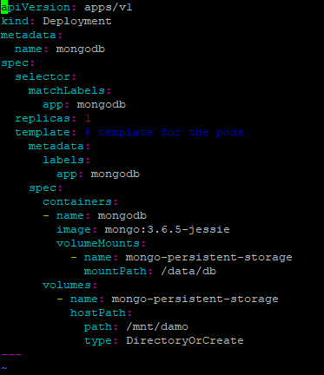
apiVersion: apps/v1
kind: Deployment
metadata:
name: mongodb
spec:
selector:
matchLabels:
app: mongodb
replicas: 1
template: # template for the pods
metadata:
labels:
app: mongodb
spec:
containers:
- name: mongodb
image: mongo:3.6.5-jessie
volumeMounts:
- name: mongo-persistent-storage
mountPath: /data/db
volumes:
- name: mongo-persistent-storage
hostPath:
path: /mnt/damo
type: DirectoryOrCreate

EXAMPLE 2:
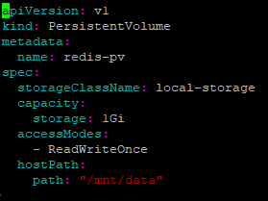
apiVersion: v1
kind: PersistentVolume
metadata:
name: redis-pv
spec:
storageClassName: local-storage
capacity:
storage: 1Gi
accessModes:
- ReadWriteOnce
hostPath:
path: "/mnt/data"
root@ip-172-31-41-82:~# kubectl get pv
NAME CAPACITY ACCESS MODES RECLAIM POLICY STATUS CLAIM STORAGECLASS REASON AGE
mongodb-pv 1Gi RWO Retain Available local-storage 5s
persistent volume claim :
apiVersion: v1
kind: PersistentVolumeClaim
metadata:
name: redisdb-pvc
spec:
storageClassName: local-storage
accessModes:
- ReadWriteOnce
resources:
requests:
storage: 1Gi
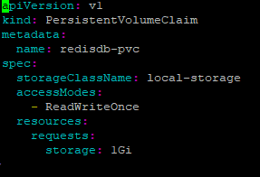

Create one pod
apiVersion: v1
kind: Pod
metadata:
name: redispod
spec:
containers:
- image: redis
name: redisdb
volumeMounts:
- name: redis-data
mountPath: /data
ports:
- containerPort: 6379
protocol: TCP
volumes:
- name: redis-data
persistentVolumeClaim:
claimName: redisdb-pvc
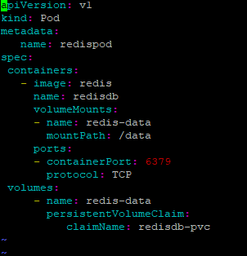

root@ip-172-31-41-82:~# kubectl exec -it redispod redis-cli
127.0.0.1:6379> SET server:name "redis server"
OK
127.0.0.1:6379> GET server:name
"redis server"
Now quit
Next delete pod
Change the pod name and apply yaml file
Again login to new pod kubectl exec -it redispod2 redis-cli
127.0.0.1:6379> GET server:name
"redis server"

REQUEST AND LIMIT:
1 Mi = 1024ki 1ki = 1024 bytes
1 M =1000k 1k=
pods/resource/cpu-request-limit.yaml
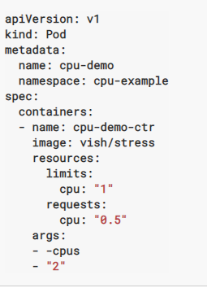
The unit suffix m stands for “thousandth of a core,” so this resources object specifies that the container process needs 50/1000 of a core (5%) and is allowed to use at most 100/1000 of a core (10%). Likewise 2000m would be two full cores, which can also be specified as 2 or 2.0.
If actual memory exceeds ,container will be killed
But if CPU exceeds ,container wont be killed it will be throttling

apiVersion: v1
kind: Pod
metadata:
name: cpu-demo
namespace: cpu-example
spec:
containers:
- name: cpu-demo-ctr
image: vish/stress
resources:
limits:
cpu: "1"
requests:
cpu: "0.5"
args:
- -cpus
- "2"
QOS:
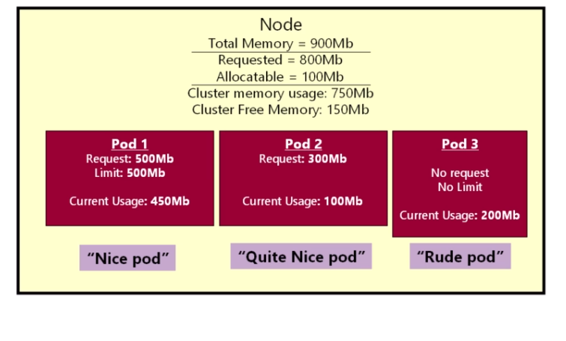POD 1- QOS:guaranteed
Pod 2 – only request no limit ----QOS: burstable
Pod 3 –QOS- Best Effort
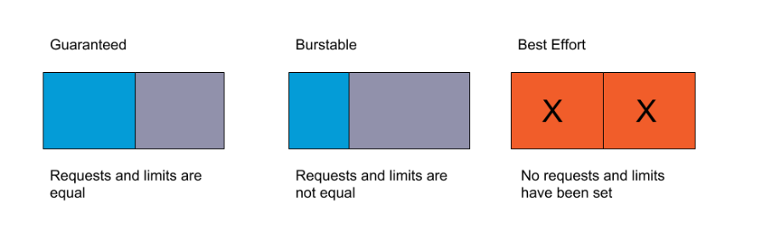
Pods are evicted only if they are using more resources than the user-defined request. This means guaranteed pods will never be evicted, burstable pods will only be evicted if they are using more of the starved resource than allowed, and best effort pods can be preempted at any time.
POD PRIORITIES:
U can give priority to pod.
Pod which will have high priority will be considered first and while eviction pod which has low priority value will be evicted. But its not used in production as in microservices architecture all the microservice application has equal weightage

